*Come,Come,Whoever You Ylre!*

*32nd Annua l S pring Ozark Sufi Camp*

*Friday M ay* 23 *through Wednesday M ay 28, 2014*

..- --

*In the beautiful lAke of the Omrks State Park, Missouri*

*lllc rv*

*Come join us in the Heartland!*

*Music, S ong, Dances of Universal Peace, Zikr, S ufi Teachings* & *Practice,*

*Prayer,Meditation,Universal Worship, Healing Temple, Dervish Turning, Tea Ceremony, Young Adults Camp, Kids Camp, Loving Community, Scrumptious Heallhy Food* & *more! with our special guests:*

*and Bernie Heideman,*

*teacher* & *Dance leader*

*joy ful Music-and-Dance Maestro*

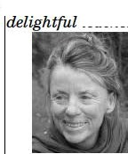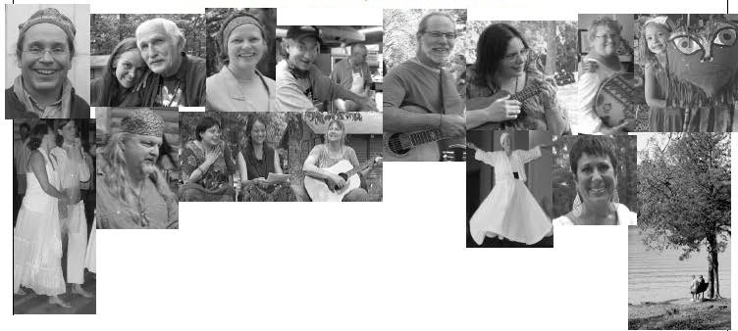

*Along with our javoite local teachers:*



*Allaudin Ottinger, Nuria Sabato, Khabtr Kitz, Firdousi Wyrick, Habiba, Rahimah, Hakima* & *others,*

*and our dedicated staff who create a beautiful space for us, musicians whose music lifts our hearts,*

*kids' camp,with fantasticfunfor* all,

*kitdum wizards who work thei'r famous food magic,*

*and all of us,who come with open heart and willing hands!*

. ...,.. . ...,.. .

.......

*· ., _,. .* • *'•)_!•' •* • ••,_ ,. . *•'•)_!•'*

*(orne, come, whoever you are,*

*'Wanderer, worshipper,{over of {eaving.*

*Ottrs is no caravan of tfeSpair!*

*'Even thougfi yott've 6ro/(s.n your vows a thousantf time..>,*

*Corne, yet again, carne.* . . -*Jelaluaam 9{J<mi*

. . '*'' •.. . .·""'·· ... . .....

*-- ·* • • *•)_J •* • • *·J.* • .,_,.

*Camp Directors: Hakima Tomi Greentree* & *Gayan Angie Galik*

*Scholarships are available. To find out more,and for registration,visit: shininghenrtcommuttity.org*

2014 Spring Ozark Sufi Camp Registration Form

Name(s).: _ Child(ren) name,gender,age (important for meal planning):

Street Address: _ City/State/ZIP:. _ Preferred Phone: Preferred E-mail: _

_ Opt Out of Camp Roster (your contact info will not be shared,nor will you receive a roster)

Emergency Contact Name: Phone.: _

Arriving (day/time).:

(important for meal planning)

Departing (day/time):.

(mi

portant for mealplaming)

SpecialDietary Considerations:. _ Gabin Preference (cirde): Family Couples Women Men Easy Access ()

camperNehicle Pin Qak Pin Oak (Young Adult)

Commen:. _

Do you have a confirmed scholarship? If yes,circle whichtype: Full Half

Scholarship position(s).: _

Deposit ($100 per adult minimum) $. _ Opt Out Karma Yoga ($20/day or$100 camp) s. _

Thursday (if not on scholarship/Staff or without permission

from camp manager, $50 per adult) $. _

Insurance Surcharge of $10 per person for everyone age 3 and up

including scholarship recipients

TotalNumber of Campers x $10 each = $. _

Total Amount Enclosed $. _ Balance due $

Due in Fullby May 1,2014"(p' '..o,..s,.t,"m'"a'"r'k"e'"d")"---

Please make check payable to Shining Heart Community and mai to the Registrar: Hailma Susan Schabilion,510 Rdi geway Ave. Coul mbia,MO 65203

Questions? Call her at (573) 81 352

Please *do* nor *mail* regisrrarion *fonn after May 16; bring* ir *wil/1 you* ro *camp!*