5 August 2016

Very dear brothers and sisters,

This is to inform you that effective July 5, 2016 Murshid Hidayat Inayat-Khan issued his official resignation, and his nomination of Murshid Nawab Pasnak as his successor to the position of Joint General Representative.

In accordance with the Articles of Incorporation of the International Headquarters of the Sufi Movement, the Executive Committee acknowledged Murshid Hidayat Inayat-Khan’s resignation from the position of Joint General Representative. We shall be eternally grateful for all the decades of faithful, loving service, and self-sacrifice rendered by both Murshid Hidayat and Murshida Aziza. We hold them in our hearts with prayers for a continued long life.

Further, in accordance with the Articles of Incorporation of the International the Executive Committee has voted overwhelmingly in support of the appointment of Murshid Nawab Pasnak to the position of Joint General Representative.

It is with great joy and optimistic enthusiasm that I share with news with all of you. Please join me in welcoming Murshid Nawab – giving him our full support, well wishes, and prayers for all ‘Blessings from Above’ – as he takes on this new post and increased responsibilities.

May his every step and action be graced with God’s Blessings filled with the light of inspiration and boundless wisdom.

With all love, light, joy!

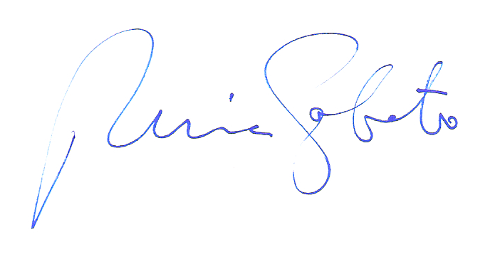

Nuria Sabato

Joint General Representative